Creating an App using SqLite Database using FireFox SQLite Manager

**Download week8.zip files for source help**

Describe and demonstrate how to create a SQLite database to use in an iOS Application.

1. Create new Utility App to desktop  
   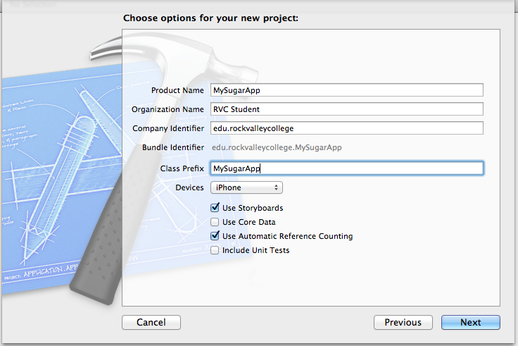
2. Create a group named, “database”
3. Fork <https://github.com/ccgus/fmdb> to your github
4. Download Zip file of FMDB repository
5. Import all **src** folder contents into “database” group, except for **fmdb.m**   
   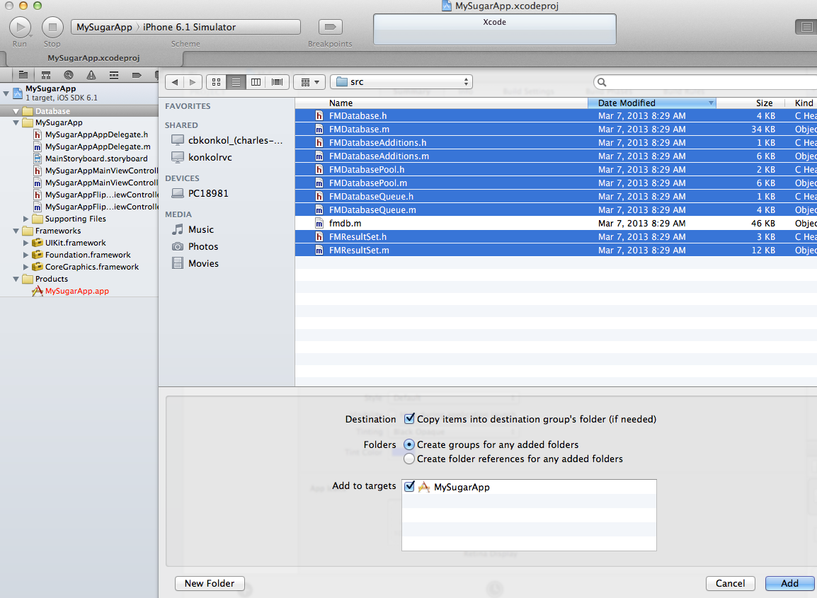
6. Download and Install SQLite Manager for FireFox

* <https://addons.mozilla.org/en-us/firefox/addon/sqlite-manager/>

1. Create new database name **MySugarApp**
2. Create table **MySugar.** 
   1. **Table > Create Table**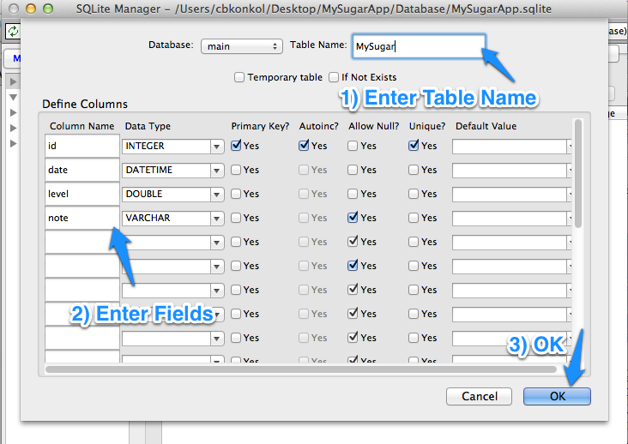
   2. id, integer, not null, primary key, autoincrement, unique
   3. date, datetime, not null
   4. level, Double, not null
   5. note, varchar, can be null
   6. OK
   7. YES  
      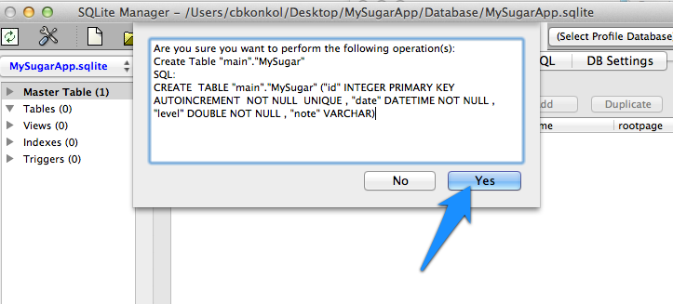
3. Add one record (do not fill on id field. Auto increment does this for you)
   1. Click on table name
   2. Click **Browse and Search**
   3. Click **Add**
   4. Enter one record

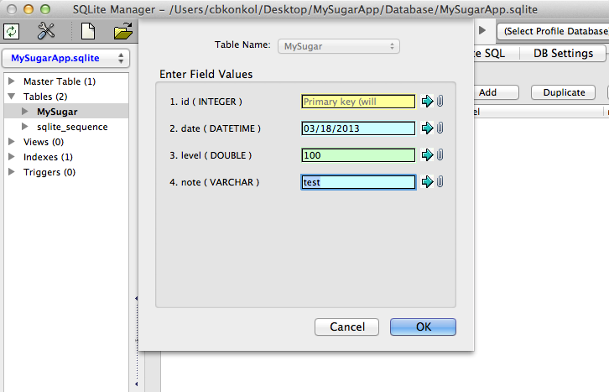  
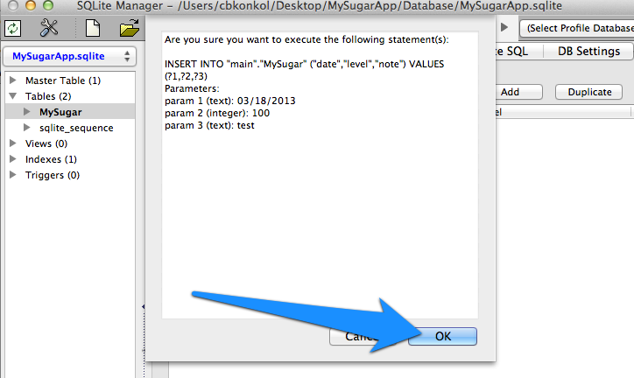  
  
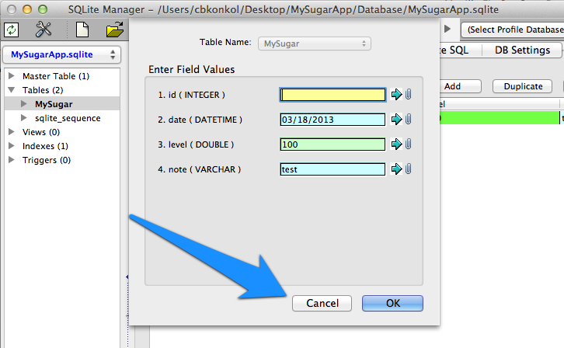

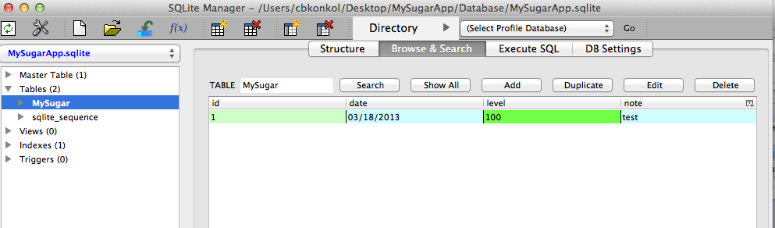

1. Copy database for iOS app into “Supporting File” folder
   1. Database > Copy
   2. Name it  **MySugar**
   3. OK
   4. Find main folder of your project and save  
      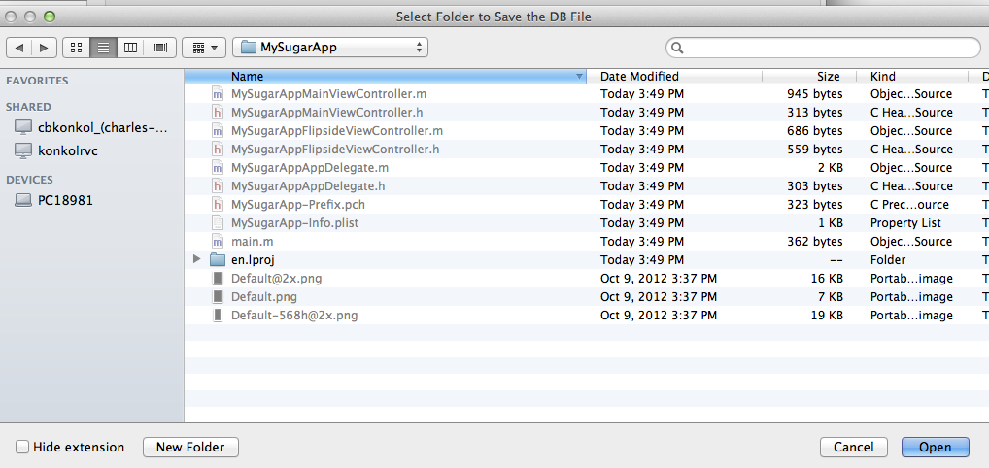
   5. Click **OPEN**
   6. 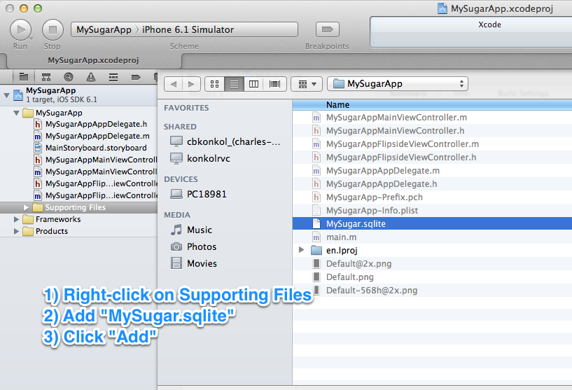
2. Now Database, Tables have been created, FMDB files have been added. We are ready to start coding
3. Add Objects to **My Sugar App Main View Controller Scene**

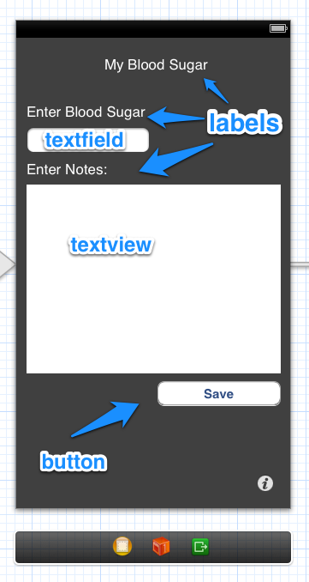

1. Add NEW View Controller and add Objects to FlipSide ViewController

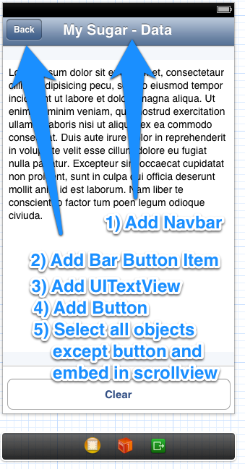

1. Embed Objects in ScrollView (Leave out bottom 2 buttons)
   1. 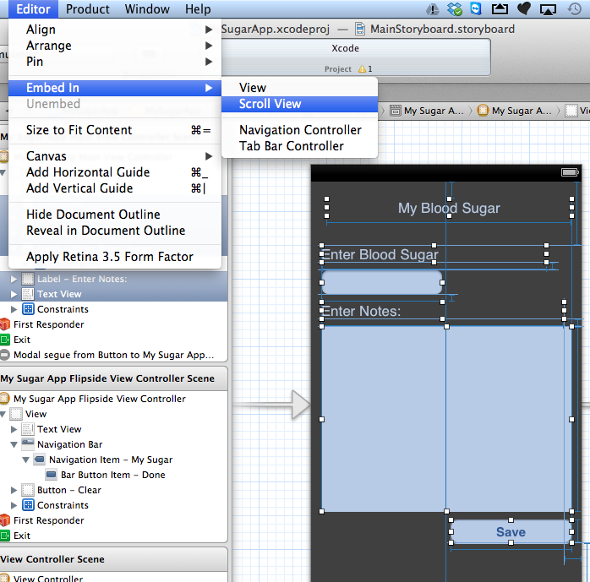

15) Add Seque from ViewController to MainView

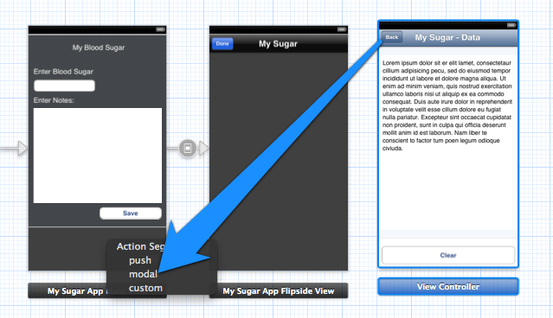

16) Add sqlite reference

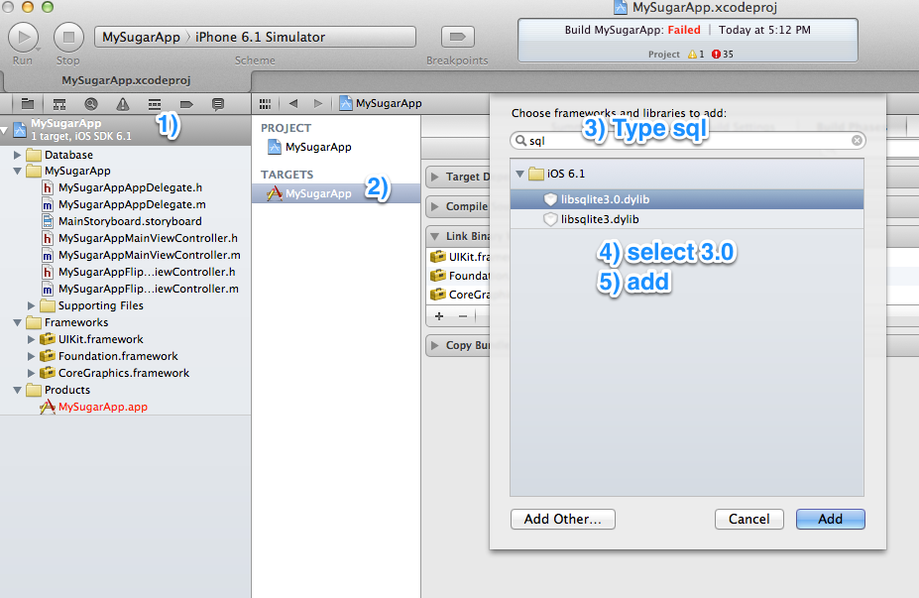

17) Run App (Command + R}. What are we missing?

18) Add a new button and change to detail disclosure

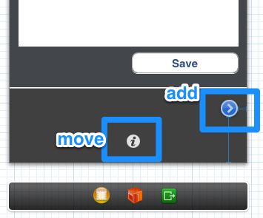

19) Add Segue to new button and ViewController

20) Run Again (Command + R)

21) Add a textview to flipside view and add description of app  
  
The Sugar App This app helps diabetics keep track of their blood sugar levels. Chuck Konkol 2013

22) Add code for MySugarAppAppDelegate.h

23)Add code for MySugarAppAppDelegate.m

24) Add code for MySugarAppMainViewController.h

25)Add code for MMySugarAppMainViewController.m

26) Add Connections, Actions, Delegates to MainView

27) Create Classes for My Sugar Data

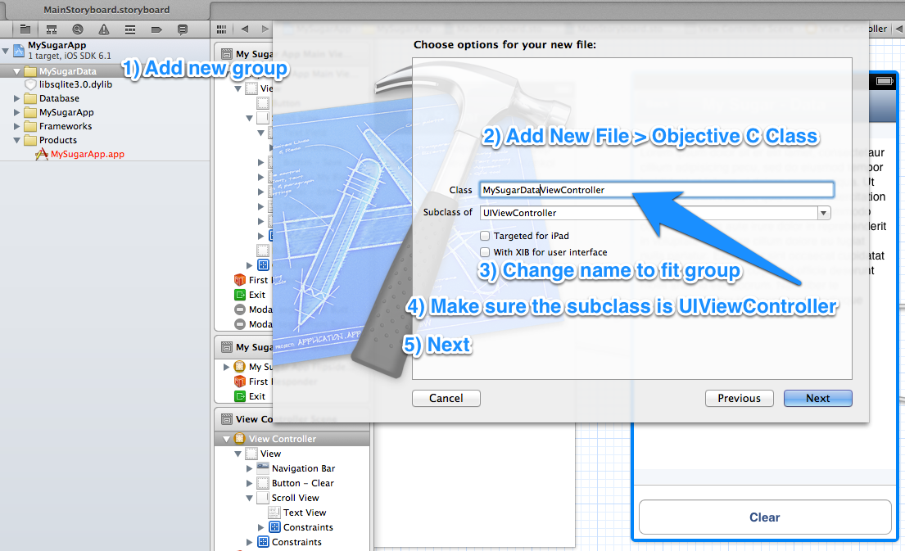

28) Add code for MySugarDataViewController.h

29)Add code for MySugarDataViewController.m

30) Add Connections, Actions, Delegates to ViewController

31) Run, Debug if Needed (Control + R)

32) Commit to GitHub